
SPECIAL COURT FOR SIERRA LEONE
JOMO KENYATTA ROAD • FREETOWN • SIERRA LEONE
PHONE: +1 212 963 9915 Extension: 178 7000 or +39 0831 257000 or +232 22 295995
FAX: Extension: 178 7001 or +39 0831 257001 Extension: 174 6996 or +232 22 295996

IN THE APPEALS CHAMBER

Before: Justice Jon M. Kamanda, President
Justice Emmanuel Ayoola
Justice George Gelaga King
Justice Renate Winter
Justice Shireen Avis Fisher

Registrar: Binta Mansaray

Date: 10 January 2011

PROSECUTOR Against CHARLES GHANKAY TAYLOR
(Case No: SCSL-03-01-T)

______________________________________________________________________________ PUBLIC
DECISION ON URGENT PROSECUTION MOTION TO CLASSIFY AS “CONFIDENTIAL” THE ‘PUBLIC DEFENCE NOTICE OF APPEAL AND SUBMISSIONS REGARDING THE DECISION ON THE DEFENCE MOTION FOR ADMISSION OF DOCUMENTS AND DRAWING OF AN ADVERSE INFERENCE RELATING TO THE ALLEGED DEATH OF JOHNNY PAUL KOROMA’ DUE TO PROTECTIVE MEASURES VIOLATIONS

Office of the Prosecutor | Counsel for the Accused
Ms. Brenda J. Hollis  Ms. Leigh Lawrie  Mr. Nathan Quick | Mr. Courtenay Griffiths, Q.C.  Mr. Terry Munyard  Mr. Morris Anyah  Mr. Silas Chekera  Mr. James Supuwood
THE APPEALS CHAMBER of the Special Court for Sierra Leone (“Special Court”),
NOTING the “Decision on Public with Confidential Annexes A-D Defence Motion for Admission of Documents and Drawing of an Adverse Inference Relating to the Alleged Death of Johnny Paul Koroma” issued by Trial Chamber II on 11 November 2010 (“Admission Decision”);
NOTING the “Decision on Defence Motion Seeking Leave to Appeal the ‘Decision on the Defence Motion for Admission of Documents and Drawing of an Adverse Inference Relating to the Alleged Death of Johnny Paul Koroma’” (“Leave Decision”), issued by Trial Chamber II on 2 December 2010;
NOTING the “Public Notice of Appeal and Submissions Regarding the Decision on the Defence Motion for Admission of Documents and Drawing of an Adverse Inference Relating to the Alleged Death of Johnny Paul Koroma” filed on 10 December 2010 (“Admission Appeal”);
NOTING the “Prosecution Response to the Public Notice of Appeal and Submissions Regarding the Decision on the Defence Motion for Admission of Documents and Drawing of an Adverse Inference Relating to the Alleged Death of Johnny Paul Koroma” filed confidentially on 17 December 2010 (“Response to the Appeal”);
BEING SEISED of the “Urgent Prosecution Motion to Classify as “Confidential” the ‘Public Defence Notice of Appeal and Submissions Regarding the Decision on the Defence Motion for Admission of Documents and Drawing of an Adverse Inference Relating to the Alleged Death of Johnny Paul Koroma’ Due to Protective Measures Violations”, (“Motion”) with Confidential Annex A, filed confidentially on 15 December 2010;
NOTING the “Defence Response to ‘Urgent Prosecution Motion to Classify as “Confidential” the ‘Public Defence Notice of Appeal and Submissions Regarding the Decision on the Defence Motion for Admission of Documents and Drawing of an Adverse Inference Relating to the Alleged Death of Johnny Paul Koroma’ Due to Protective Measures Violations” filed confidentially on 16 December 2010 (“Response”);
NOTING that the Prosecution has not filed a reply thereto;
ALSO NOTING the “Confidential Decision on Confidential with Confidential Annex A Urgent Prosecution Motion to Classify as ‘Confidential’ Certain Public Filings and Decisions in Violation of Protective Measures, issued by Trial Chamber II on 16 December 2010 (“Confidentiality Decision”);
NOTING the Prosecution’s submission that paragraphs 7, 9 45, 50 and 51 of the Admission Appeal violate the 25 June 2008 Decision of Trial Chamber II in that they reveal information provided in private session by Witness TF1-375 about the alleged murder of Johnny Paul Koroma, that will allow Witness TF1-375’s sources to identify him;
RECALLING that in its Decision of 25 June 2008, Trial Chamber II granted additional protective measures for Witness TF1-375 and ordered that all testimony relating to the death of Johnny Paul Koroma be adduced in private session;
NOTING that the Defence did not oppose the Trial Chamber’s Decision of 25 June 2008 at that time;
NOTING the Defence Response wherein it refutes the Prosecution’s assertions regarding paragraphs 7 and 9 of the Admission Appeal and contends that they contain ‘vague references’ to Witness TF1-375 and ‘cannot plausibly be said to identify him,’ and further submits that page references to private session transcripts do not put the Witness’s identity at risk since the content of those transcripts are not available to the public;
NOTING further that the Defence does not object to the classification of the Admission Appeal as “Confidential” and the filing of a public redacted version in respect of information contained in paragraphs 45, 50 and 51 respectively;
NOTING that paragraphs 7 and 9 of the Admission Appeal produce verbatim the discussions of Trial Chamber II in its public Admission Decision and public Disclosure Decision respectively;
RECALLING the Confidentiality Decision wherein the Trial Chamber found that the Admission Decision and the Disclosure Decision do not disclose any information which could potentially identify Witness TF1-375 and therefore do not violate its protective measures Order of 25 June 2008;
CONSIDERING therefore that paragraphs 7 and 9 of the Admission Appeal fall outside the scope of the Trial Chamber II Decision of 25 June 2008;
HEREBY GRANTS the Prosecution Motion IN PART; INSTRUCTS the Court Management Section of the Special Court to reclassify the Admission Appeal as “confidential”; and ORDERS that:
- the Defence files a public redacted version of the Admission Appeal which redacts information at paragraphs 45, 50 and 51 respectively, no later than 16:00 hrs on Tuesday, 11 January 2011;

- the Prosecution files a public redacted version of its Confidential Response to the Admission Appeal, no later than 16:00 hrs on Wednesday, 12 January 2011;
- any reply to the Response be filed no later than 16:00 hrs on Friday, 14 January 2011.

Dated this 10th day of January 2011 at Freetown, Sierra Leone.

Justice Jon M. Kamanda  President | 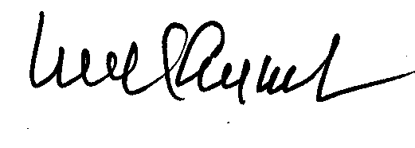  Justice Emmanuel Ayoola |  | 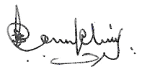  Justice George Gelaga King
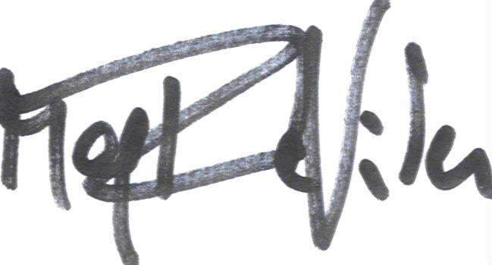  Justice Renate Winter |  | 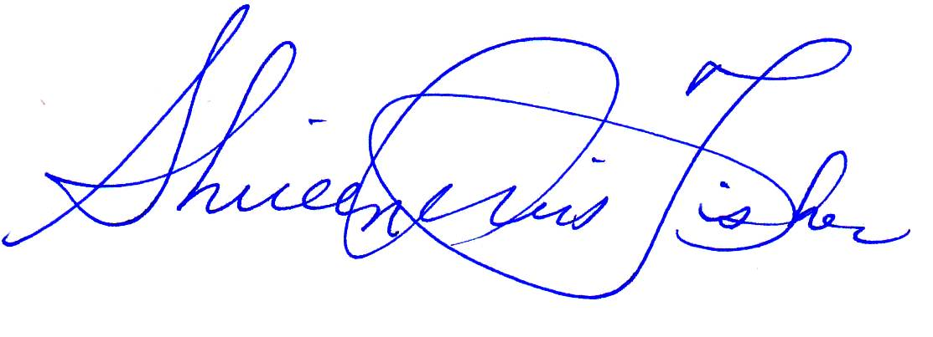  Justice Shireen Avis Fisher

Prosecutor v Taylor, SCSL-03-01-T-1140 “Confidential Decision on Confidential with Confidential Annex A Urgent Prosecution Motion to Classify as "Confidential" Certain Public Filings and Decisions in Violation of Protective Measures” 16 December 2010 (“Confidential Decision”).
Prosecution Motion, para. 5; referencing Prosecutor v Taylor, SCSL-03-01-T, Trial Transcript (Private), 25 June 2008, pp. 12741-2.
Prosecutor v Taylor, SCSL-03-01-T, Trial Transcript (Private), 25 June 2008, pp. 12741-2.
Defence Response, para. 4.
Prosecutor v Taylor, Decision on Public with Confidential Annexes A-D Defence Motion for Admission of Documents and Drawing of an Adverse Inference Relating to the Alleged Death of Johnny Paul Koroma” 11 November 2010 (“Admission Decision”), paras 23-25.
Prosecutor v Taylor, Decision on Public with Confidential Annexes A-D Defence Motion for Disclosure of Exculpatory Information Relating to DCT-032, 20 October 2010 (“Disclosure Decision”), paras 1,2 and 24.
Prosecutor v Taylor, SCSL-03-01-T-1140 “Confidential Decision on Confidential with Confidential Annex A Urgent Prosecution Motion to Classify as "Confidential" Certain Public Filings and Decisions in Violation of Protective Measures, 16 December 2010, pp.3.

