o
SPECIAL COURT FOR SIERRA LEONE
JOMO KENYATTA ROAD • FREETOWN • SIERRA LEONE
PHONE: +1 212 963 9915 Extension: 178 7000 or +39 0831 257000 or +232 22 295995
FAX: Extension: 178 7001 or +39 0831 257001 Extension: 174 6996 or +232 22 295996

IN THE APPEALS CHAMBER

Before: | Justice George Gelaga King, Presiding Judge  Justice Emmanuel Ayoola  Justice Renate Winter  Justice Raja Fernando  Justice Jon Kamanda
Registrar: | Herman von Hebel
Date: | 21 January 2008
PROSECUTOR | Against | Moinina Fofana  Allieu Kondewa  (Case No.SCSL-2004-14-A)

DECISION ON THE REQUEST BY HUMAN RIGHTS WATCH FOR LEAVE TO APPEAR AS AMICUS CURIAE PURSUANT TO RULE 74

Office of the Prosecutor: |  | Defence Counsel for Moinina Fofana:
Dr. Christopher Staker  Mr. Karim Agha  Mr. Chile Eboe-Esuji  Mr. Joseph Kamara  Ms. Anne Althaus |  | Mr. Wilfred Davidson Bola Carol
Defence Counsel for Allieu Kondewa:
Mr. Yada Williams

The Appeals Chamber (“Appeals Chamber”) of the Special Court for Sierra Leone (“Special Court”) composed of Justice George Gelaga King, Presiding Judge, Justice Emmanuel Ayoola, Justice Renate Winter, Justice Raja Fernando and Justice Jon Kamanda,
SEISED of the Appeals filed by the Prosecution and Allieu Kondewa against the Judgments rendered by Trial Chamber I in the case of Prosecutor v Fofana and Kondewa;
SEISED of the Request by Human Rights Watch (“Applicant”) dated 6 December 2007 for Leave to Appear as Amicus Curiae in the Prosecution Appeal against the “Judgment on the Sentencing of Moinina Fofana and Allieu Kondewa” (“Sentencing Judgment”) rendered on 9 October 2007 by Trial Chamber I (“HRW Application”);
CONSIDERING Fofana’s “Response to the Request for Leave to Appear as Amicus Curiae Pursuant to Rule 74 by Human Rights Watch” dated 10 December 2007 (“Fofana Response”);
CONSIDERING the Prosecution “Submissions on the Request for Leave to Appear as Amicus Curiae Pursuant to Rule 74” Filed by Human Rights Watch on 6 December 2007” dated 14 December 2007 (“Prosecution Submissions”);

HEREBY DECIDES the Motion on the basis of the written submissions filed by the parties:

I. SUBMISSIONS

- Human Rights Watch requests leave to file an amicus curiae brief in the Prosecution appeal against the Sentencing Judgment of Trial Chamber I, in the case of Prosecutor v Fofana and Kondewa. The Applicant’s request relates to the finding of the Trial Chamber that “the defendants’ motivation to restore a democratically elected government was a mitigating circumstance.”
- The Applicant submits that it “believes…it has valuable information regarding the nature and enforcement of international humanitarian law, and the practice of national and international tribunals in adjudicating war crimes that will assist the Appeals Chamber in reviewing the Sentencing Judgment.” Human Rights Watch states that its amicus curiae brief would seek to explain the role of sentencing and that of mitigating circumstances in the enforcement of international humanitarian law. The Applicant submits therefore, that the Trial Chamber’s reliance on the relative legitimacy of the goal for which the Accused fought as a mitigating circumstance is wholly inconsistent with international humanitarian law.
- In response, Fofana submits that the Appeals Chamber is fully capable of handling issues pertaining to sentencing and mitigating factors; that the Applicant has not demonstrated that its submissions would be essential to the Chamber’s deliberations, and that granting the request for leave will substantially delay the appeal process and interfere with the fair trial rights of Fofana and Kondewa.
- The Prosecution submits that the proposed amicus curiae brief would be desirable for the proper determination of the issues before the Appeals Chamber. However, the Prosecution concede that it is ultimately for the Appeals Chamber to decide whether or not it would be assisted by the proposed amicus curiae submissions.

II. DELIBERATIONS

- Trial Chamber I delivered its Judgment in the case of the Prosecutor v Fofana and Kondewa on 2 August 2007 and the Sentencing Judgment on 9 October 2007. The Prosecution and the Accused Kondewa filed Notices and Grounds of Appeal on 23 October 2007 and 11 December 2007 respectively.
- The procedure for filing amicus curiae applications before the Special Court is governed by Rule 74 of the Rules of Procedure and Evidence of the Special Court and the Practice Direction on Filing Amicus Curiae Applications (“Practice Direction”).
- Rule 74 and the Practice Direction confer discretion on a Trial Chamber or the Appeals Chamber to determine whether to grant a request to file an amicus curiae brief. In exercising that discretion, the primary criterion is whether the proposed submissions would assist the Chamber reach a proper determination of the issues on appeal.
- Information regarding the nature and enforcement of international humanitarian law as well as that relating to the practice of both national and international tribunals is readily available to the Appeals Chamber. Furthermore, the Appeals Chamber is certainly composed of Judges of sufficient professional standing and experience, fully capable of assessing the law and practice of international and domestic courts relating to sentencing, including mitigating circumstances. An amicus curiae brief in this matter is therefore unnecessary.

FOR THE FOREGOING REASONS, THE APPEALS CHAMBER

DENIES the Request of Human Rights Watch for leave to file an amicus curiae brief.

Done at Freetown this 21 day of January 2008.

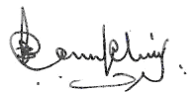  Justice George Gelaga King  Presiding | 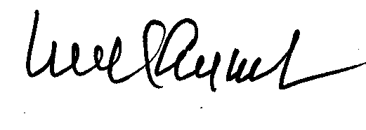  Justice Emmanuel Ayoola |  | 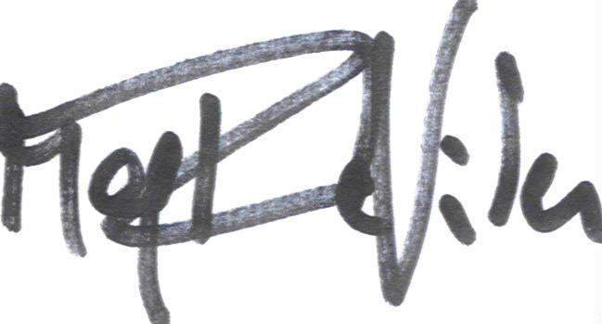  Justice Renate Winter
  Justice Raja Fernando |  | Justice Jon Kamanda

[Seal of the Special Court for Sierra Leone]

Prosecutor v Fofana and Kondewa, SCSL-04-14-T, Trial Chamber, Judgment, 2 August 2007; Prosecutor v Fofana and Kondewa, SCSL-04-14-T, Trial Chamber, Judgment On The Sentencing Of Moinina Fofana And Allieu Kondewa, 9 October 2007; Prosecutor v Fofana and Kondewa, SCSL-04-14-A, Kondewa Notice of Appeal Against Judgment Pursuant To Rule 108, 23 October 2007; Prosecutor v Fofana and Kondewa, SCSL-04-14-A, Prosecution’s Notice of Appeal, 23 October 2007.
Prosecutor v Fofana and Kondewa, SCSL-04-14-A-806, Request For Leave To Appear As Amicus Curiae Pursuant to Rule 74, paras. 5,6.
Fofana Response, paras. 9, 10, 11and 12.
Prosecutor v Fofana and Kondewa; SCSL-04-14-A-806, Prosecution Submissions On The Request For Leave To Appear As Amicus Curiae Pursuant to Rule 74 Filed by Human Rights Watch on 6 December 2007.
Rule 74 provides: “A Chamber may, if it considers it desirable for the proper determination of the case, invite or grant leave to any State, organisation or person to make submissions on any issue specified by the Chamber.”
Practice Direction On Filing Amicus Curiae Applications Before The Special Court, 20 October 2004, Article 1(1) states: “[a]pplications for leave to make written or oral submissions as amicus curiae may be submitted at the applicant’s own initiative or in response to a general invitation from a Chamber.”
Prosecutor v Kallon, SCSL-03-07-PT, Decision On Application By The Redress Trust, Lawyers Committee For Human Rights And The International Commission of Jurists For Leave To File An Amicus Curiae Brief And To Present Oral Submissions, 1 November 2003, para. 3; Prosecutor v Ante Gotovina et. Al., IT-06-90-AR108bis 1, International Criminal Tribunal for the Former Yugoslavia, Appeals Chamber, Decision On Prosecution’s Motion To Strike Request For Review Under Rule 108bis, 13 December 2006, para. 7; Prosecutor v Jadranko Prlic, IT-04-74-AR108bis.1, International Criminal Tribunal for the Former Yugoslavia, Appeals Chamber, Decision on Prosecution’s Motion To Strike Request For Review Under Rule 108bis, 13 December 2006, para. 7; See also: “Information Concerning The Submission Of Amicus Curiae Briefs Before The ICTY”, 27 March, 1997, IT/122, paras. 2 and 5(c).
Prosecutor v Kallon, SCSL-03-07-PT, supra, para. 5: The Appeals Chamber stated that “[t]he issue is whether it is desirable to receive such assistance, and “desirable” does not mean “essential” (which will be over-restrictive) nor does it have an over-permissive meaning such as “convenient” or “interesting”. The discretion will be exercised in favour of an application where there is a real reason to believe that written submissions, or such submissions supplemented by oral argument, will help the Court to reach the right decision on the issue before it.” See also: Prosecutor v Radoslav Brdanin, IT-99-36-A, International Criminal Tribunal for the Former Yugoslavia, Appeals Chamber, Decision On Association Of Defence Counsel Request To Participate In Oral Argument, 7 November 2005, p. 3; Prosecutor v Kayishema, ICTR-05-87-I, International Criminal Tribunal for Rwanda, Trial Chamber, Decision On The Amicus Curiae Request Of The Defence Of Gaspard Kanyarukiga, 14 September 2007, para. 7; Prosecutor v Nahimana, ICTR-99-52-A, International Criminal Tribunal for Rwanda, Appeals Chamber, Decision On The Admissibility of The Amicus Curiae Brief Filed By The Open Society Justice Initiative And On Its Request To Be Heard At The Appeals Hearing, 12 January 2007, p. 3; Prosecutor v Semanza, ICTR-97-20-A, International Criminal Tribunal for Rwanda, Appeals Chamber, Decision On Amicus Curiae Application Of Paul Bisengimana, 30 March 2004, p. 3; Prosecutor v Bagasora et al., ICTR-98-41-T, International Criminal Tribunal for Rwanda, Trial Chamber, Decision On Amicus Curiae Request By African Concern, 23 March 2004, para. 4; Prosecutor v Musema, ICTR-96-13-T, International Criminal Tribunal for Rwanda, Trial Chamber, Decision On An Application by African Concern For Leave To Appear As Amicus Curiae, 17 March 1999, para. 2.

