o
SPECIAL COURT FOR SIERRA LEONE
JOMO KENYATTA ROAD • FREETOWN • SIERRA LEONE
PHONE: +1 212 963 9915 Extension: 178 7000 or +39 0831 257000 or +232 22 295995
FAX: Extension: 178 7001 or +39 0831 257001 Extension: 174 6996 or +232 22 295996

IN THE APPEALS CHAMBER

Before: | Justice Renate Winter, Pre-Hearing Judge
Registrar: | Herman von Hebel, Registrar
Date: | 24 August 2007
PROSECUTOR | Against | Alex Tamba Brima  Brima Bazzy Kamara  Santigie BORBOR Kanu  (Case No.SCSL-2004-16-A)

DECISION ON URGENT PROSECUTION MOTION
FOR AN EXTENSION OF THE PAGE LIMIT FOR ITS APPEAL BRIEF

Office of the Prosecutor: |  | Defence Counsel for Alex Tamba Brima:
Dr. Christopher Staker |  | Mr. Kojo Graham  Defence Counsel for Brima Bazzy Kamara:
 |  | Mr. Andrew Daniels
Defence Counsel for Santigie Borbor Kanu:
Mr. Agibola E. Manley-Spain

I, RENATE WINTER, the Pre-Hearing Judge in this case,

SEISED of the “Urgent Prosecution Motion for an Extension of the Page Limit for its Appeal Brief” filed on 2 August 2007 (the “Motion”);
HAVING Received and Considered the “Brima – Kamara Joint Response to Urgent Prosecution Motion for an Extension of the Page Limit for its Appeal Brief” filed on 20 August 2007 (the “Response”) and the “Urgent Prosecution Reply to Brima – Kamara Response to Prosecution Motion for an Extension of the Page Limit for its Appeal Brief” filed on 22 August 2007 (the “Reply”);
NOTING that Kanu has not filed a response within the time limit stipulated under Rule 7(C) of the Rules of Procedure and Evidence;

HEREBY DECIDES:

SUBMISSIONS
- The Prosecution requests an extension of the page limit for its appeal brief to no more than 250 pages. The Prosecution recalls Article 6(E)(i) of the Practice Direction on Filing Documents before the Special Court for Sierra Leone, which limits the Prosecution’s consolidated appeal brief to 170 pages or 50,000 words, whichever is greater. The Prosecution notes that it is not obliged to file a consolidated appeal brief, and it is seeking an upper limit of 250 pages which is less than the combined page limit of 300 which would apply if the Prosecution were to file separate briefs in respect of each convicted person. Therefore, the Prosecution submits that the motion for an extension of the page limit to 250 is proportionate, reasonable, and necessary to enable the Prosecution to adequately address all of its nine grounds of appeal.
- In their Response, Brima and Kamara do not object to the Prosecution’s motion, but request that should the Appeals Chamber decide to grant the Prosecution request, they should similarly be granted an extension of 20 pages each so as to allow them to “adequately respond to all matters of fact and law raised by the Prosecution in their written submissions.”
- The Prosecution also filed a Reply in which it submits that it is premature for the Defence to request an extension of the page limit for their responses to the Prosecution’s appeal brief before it is filed.

DELIBERATIONS
- Article 6(G) of the Practice Direction on Filing Documents before the Special Court for Sierra Leone empowers a Judge or Chamber of the Special Court to authorize an extension of the page limits prescribed in Article 6(E) where the Party seeking such an extension shows the existence of ‘exceptional circumstances that necessitate the oversized filing’.
- I am persuaded by the Prosecution submission that its nine grounds of appeal and the length and complexity of the Trial Judgement constitute exceptional circumstances warranting an extension of the page limit for its consolidated brief.
- Furthermore, it is my opinion that the joint response filed by Brima and Kamara must be understood as a request for an extension of the page limit for their appeal briefs, and not as a request relating to their responses to the Prosecution’s yet-to-be-filed consolidated appeal brief.
- Kanu has neither filed a response to the Prosecution’s Motion nor requested an extension of the page limit for its appeal brief. Nevertheless, as the Statute of the Special Court requires equal treatment of persons similarly situated before it, a privilege accorded to one convicted person must be accorded to all others.

FOR THE FOREGOING REASONS,

I HEREBY GRANT the Motion and authorise the Prosecution to file an appeal brief of no more than 250 pages and authorise extensions of no more than 20 pages each for the appeal briefs of Brima and Kamara. I hereby further authorise that Kanu may also file an appeal brief with an extension of no more than 20 pages.

Done at Freetown this 24th Day of August 2007.

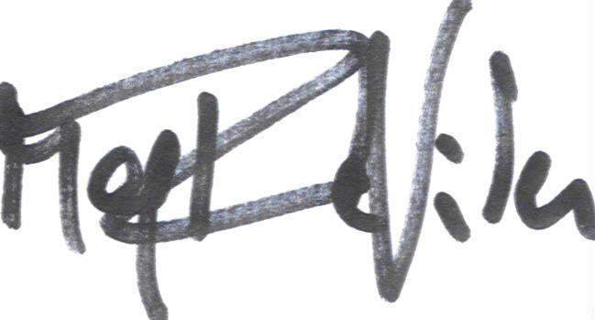

Renate Winter
Pre-Hearing Judge

[Seal of the Special Court for Sierra Leone]

Brima – Kamara Joint Response to Urgent Prosecution Motion for an Extension of the Page Limit for its Appeal Brief, Case No. SCSL-2004-16-A, 20 August 2007, para. 5.

