o
SPECIAL COURT FOR SIERRA LEONE
JOMO KENYATTA ROAD • FREETOWN • SIERRA LEONE
PHONE: +1 212 963 9915 Extension: 178 7000 or +39 0831 257000 or +232 22 295995
FAX: Extension: 178 7001 or +39 0831 257001 Extension: 174 6996 or +232 22 295996

IN THE APPEALS CHAMBER

Before: | Justice George Gelaga King, Presiding Judge  Justice Emmanuel Ayoola  Justice Renate Winter  Justice Geoffrey Robertson, QC  Justice Raja Fernando
Registrar: | Herman von Hebel
Date: | 25 July 2007
PROSECUTOR | Against | Alex Tamba Brima  Brima Bazzy Kamara  Santigie BORBOR Kanu  (Case No. SCSL-2004-16-A)

DECISION ON REQUEST FOR EXTENSION OF TIME PURSUANT TO
RULE 116 OF THE RULES OF PROCEDURE AND EVIDENCE

Office of the Prosecutor: |  | Defence Counsel for Alex Tamba Brima:
Christopher Staker  Karim Agha |  | Kevin Metzger  Glenna Thompson  Defence Counsel for Brima Bazzy Kamara:
Wilbert Harris
Mohamed Pa-Momo Fofanah

Defence Counsel for Santigie Borbor Kanu:
Geert-Jan A. Knoops, Lead Counsel
Carry J. Knoops, Co-Counsel
A.E. Manly-Spain, Co-Counsel

THE APPEALS CHAMBER (“Appeals Chamber”) of the Special Court for Sierra Leone (“Special Court”) composed of Justice George Gelaga King, Presiding Judge, Justice Emmanuel Ayoola, Justice Renate Winter, Justice Geoffrey Robertson, QC, and Justice Raja Fernando;

SEISED of the “Urgent Joint Defence Request for Extension of Time Limit Pursuant to Rule 116 for Filing of Notice of Appeal and Appeal Submissions,” filed on 13 July 2007 (the “Request”);

RECALLING that in the Request Mr. Metzger, Mr. Harris, and Mr. Knoops seek an extension of time of four months for filing the notice of appeal and a delay of four months for all other deadlines, running from the signing of contracts by the counsel for the three convicted persons with the Defence Office for the appeals phase;

RECALLING that in the alternative Mr. Metzger, Mr. Harris, and Mr. Knoops request a suspension of time limits until certainty of counsel is achieved, with liberty to thereafter revisit the issue of extension of time limits;

CONSIDERING that Mr. Metzger and Mr. Harris argue that the Rules of Evidence and Procedure of the Special Court for Sierra Leone (the “Rules”) provide for extremely short time limits for the appeals phase, particularly in contrast to the comparable provisions of the ICTY and the ICTR, and the Rules do not take into consideration the possibility of a change of counsel;

CONSIDERING that Mr. Metzger and Mr. Harris further argue that the volume of the judgment and the evidence from the trial gives rise to exceptional circumstances and necessitates the devotion of a considerable amount of time by counsel who have not been present for most of the trial;

CONSIDERING that Mr. Knoops argues that for reasons of judicial economy, the same extension of time should apply to himself so as to prevent the cases from being split up and to enable the Court and the Prosecution to handle all appeals simultaneously;

CONSIDERING that the three convicted persons argue that none of the teams have been able to spend time preparing for the appeals phase because any time expended would not be remunerated because of the absence of contracts with the Defence Office for the appeals phase;

CONSIDERING that the three convicted persons further argue that allowing appeals deadlines to run in the absence of formal legal counsel would violate the convicted persons’ right to fair trials;

CONSIDERING that the Prosecution argues that the Appeals Chamber should decline to entertain the Request or should dismiss it for lack of jurisdiction because it was not validly filed in any proceedings before the Special Court;

CONSIDERING that the Prosecution further argues that the Request was not validly filed because the Appeals Chamber is not presently seised of any appeal in the AFRC case, and even if it were seised of an appeal, the Appeals Chamber could not entertain motions filed by persons who have not been assigned to represent the convicted persons;

CONSIDERING that the Prosecution argues that, in the alternative, if the Appeals Chamber were to decide that the Request was validly filed, then the Appeals Chamber should dismiss the Request on its merits because the Defence has not demonstrated good cause for an extension of time;

CONSIDERING that the Prosecution further argues that once Defence counsel have been provisionally or permanently assigned in this case, the Defence counsel may raise any issue of prejudice to the Defence caused by delays in the appointment of counsel;

CONSIDERING that the Prosecution further argues that Mr. Metzger and Mr. Harris have not shown good cause for an extension of time given that they previously served as counsel for Brima and Kamara, respectively, and therefore have knowledge of the Indictment, the pre-trial brief, the opening statements, and all witness statements disclosed by the time at which they withdrew as counsel;

CONSIDERING that the Prosecution further argues that the shortness of the time limits of the Special Court for the appeals phase in contrast to the comparable time limits of the ICTY and the ICTR may not be invoked in itself as good cause for an extension of time;

CONSIDERING that in Reply to the Prosecution, Mr. Knoops argues that even though they have not been assigned yet as defence counsel, they should be allowed to have standing before the Appeals Chamber because they have a moral and ethical obligation during the trial phase to take recourse to the Appeals Chamber;

CONSIDERING that in his Reply Mr. Knoops further argues that he has good cause for an extension because the time limits for appeals are insufficient given his inability to do any preparatory work for the appeals phase until the signing of a contract for the appeals phase;

NOTING that Rule 116 of the Rules provides that the Appeals Chamber “may grant a motion to extend a time limit upon a showing of good cause”;

CONSIDERING the Appeals Chamber Decision on Defence Appeal Motion Pursuant to Rule 77(J) on Both the Imposition of Interim Measures and an Order Pursuant to Rule 77(C)(iii) in which the Appeals Chamber held that counsel for the three defendants in the AFRC trial did not have standing to prosecute an appeal against the Decisions taken by the Trial Chamber because they had not, inter alia, been assigned to represent any of the five alleged contemnors;

CONSIDERING that, effective 20 July 2007, the Principal Defender assigned Mr. Kojo Graham, Mr. Andrew Daniels, and Mr. Ajibola E. Manly-Spain as Assigned Appeal Counsel for Brima, Kamara, and Kanu, respectively;

FINDING that therefore Mr. Metzger, Mr. Harris, and Mr. Knoops all do not have locus standi to make Requests for an extension of the time limit for the notice of appeal and the appeal submissions;

FOR THE FOREGOING REASONS,

REJECTS the Requests of Mr. Metzger, Mr. Harris, and Mr. Knoops on behalf of Brima, Kamara, and Kanu for an extension of time to file the notice of appeal and appeal submissions.

Done at Freetown this 25 July 2007.

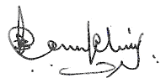  Justice George Gelaga King  Presiding | 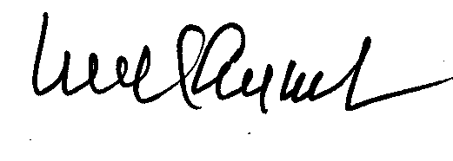  Justice Emmanuel Ayoola |  | 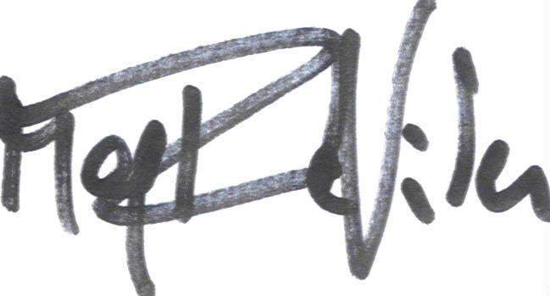  Justice Renate Winter
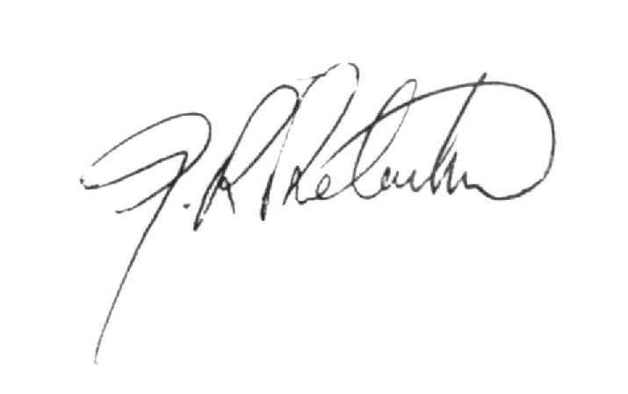  Justice Geoffrey Robertson, QC |  | 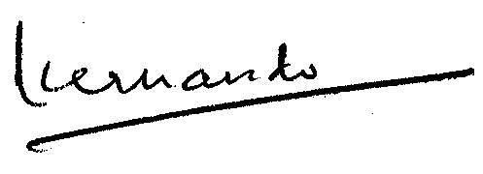  Justice Raja Fernando

[Seal of the Special Court for Sierra Leone]

Prosecutor v. Brima, Kamara, and Kanu, SCSL-04-16-AR77, Special Court for Sierra Leone, Decision on Defence Appeal Motion Pursuant to Rule 77(J) on Both the Imposition of Interim Measures and an Order Pursuant to Rule 77(c)(iii), Appeals Chamber, 23 June 2005, para. 33. See also Separate and Partial Dissenting Opinion of Justice George Gelaga King, para. 26.

